A
Project Report
On

YouTube Video View Predictor
Submitted in Partial Fulfillment of the Requirements for the Degree of

Master of Computer Applications


Kavayitri Bahinabai Chaudhari North Maharashtra University, Jalgaon
Submitted by
Mr. Borse Harshal Vitthal

Under the Guidance of
Prof. Leena Patil

GODAVARI INSTITUTE OF MANAGEMENT AND RESEARCH, JALGAON

A.Y. 2025-26

DEPARTMENT OF COMPUTER APPLICATIONS

CERTIFICATE

This is to certify that Mr. Borse Harshal Vitthal, a final year student of Master of Computer Application from Godavari Institute of Management and Research, Jalgaon has successfully completed the research project entitled YouTube Video View Predictor as a part of academic curriculum during academic year 2025-26.

Date:
Place: Jalgaon

Guide
Prof. Leena Patil

Prof. Mitali Shinde Dr. Prashant S. Warke
Co-ordinator Director

External Examiner

Acknowledgement

I take this opportunity to express my profound gratitude to my esteemed project guide Prof. Leena Patil for her excellent guidance, suggestions and constructive criticism. Working under his guidance greatly contributed in improving quality of my project work and my skills. Actually he is one of such genuine person for whom my words will not be enough to express.
I am extremely fortunate be involved in an exciting and challenging research project. It gave me an opportunity to work in new environment of Fluent. This project has improved my thinking and understanding capability.
It’s my honor to give sincere thanks to Honorable Director Dr. Prashant S. Warke, for their motivation and blessings. I also extend my sincere thanks to all faculty members of Computer department for making my project as successful one, for their valuable advice in every stage and also giving me absolute working environment where I unlashed my potential. I would like to extend my sincere thanks to my friends and colleagues.
I would like to convey my heartiest gratitude to my parents deserves more recognition than I could never acknowledge.

Borse Harshal Vitthal

Declaration

I Mr. Borse Harshal Vitthal, hereby declare that this work reported in this project entitled “YouTube Video View Predictor” submitted to KBCNMU, Jalgaon during the academic year 2025-26, is my own work and that, to the best of my knowledge and belief, it contains no material previously published or written by another person nor material which to a substantial extent has been accepted for the award of any other degree or diploma at any university or equivalent institution. I also declare that the intellectual content of this report is the product of my own work.

Date:

Borse Harshal Vitthal

Abstract

The “YouTube Video View Predictor” is a desktop-based machine learning application developed in Python that aims to predict the number of views a YouTube video may receive based on various input parameters. The system uses factors such as video duration, category, time of publishing, subscriber count, and engagement rate, number of likes, and comments to forecast view counts. It employs machine learning algorithms like Random Forest Regressor to analyze historical data and generate accurate predictions. The project helps YouTubers, marketers, and content creators understand the potential reach of their videos before publishing. By leveraging artificial intelligence, the application offers data-driven insights for better content strategy and optimization. The system includes an intuitive GUI developed using Tkinter, enabling users to input parameters easily and instantly view predicted results. Overall, this project demonstrates the integration of machine learning with practical content analytics in a user-friendly desktop environment.

INDEX
 | College Certificate |  | i
 | Acknowledgement |  | ii
 | Declaration |  | iii
 | List of Figures
 | List of Tables
 | Abstract |  | v
Sr.  No | Chapter |  | Page No.
1. | Introduction |  | i
 | 1.1 | Background and Basics | i
 | 1.2 | Motivation | i
 | 1.3 | Literature Survey | i
 | 1.4 | Problem Definition | i
 | 1.5 | Scope | i
 | 1.6 | Objective | i
 | 1.7 | Selection of Life cycle Model for Development | ii
 | 1.8 | Organization of Report | ii
2. | Project Planning and Management |  | iii
 | 2.1 | Feasibility Study | iii
 | 2.2 | Risk Analysis | iii
 | 2.3 | Project Scheduling | iii
 | 2.4 | Effort Allocation | iv
 | 2.5 | Cost Estimation | iv
3. | Analysis |  | v

 | 3.1 | Requirement Collection and Identification | v
 | 3.2 | Software Requirements Specification (SRS)  - Product Features  - Operating Environment  - Assumptions  - Functional Requirements  - Non-Functional Requirements  - External Interfaces (User, Hardware, Software, Communication) | vi,vii
4. | Design |  | viii
 | 4.1 | System Architecture | viii
 | 4.2 | Data Flow Diagram | ix
 | 4.3 | UML Diagrams (Use case, Class, Sequence, Component, Deployment, State chart, Activity diagram etc.) | x,xi
5. | Coding/Implementation |  | xiv
 | 5.1 | Algorithm/Steps | xiv
 | 5.2 | Software and Hardware for development in detail | xv
 | 5.3 | Modules in Project | xv,xvi
6. | Testing |  | xvii
 | 6.1 | Black Box/White Box testing | xvii
 | 6.2 | Manual/Automated Testing | xviii
 | 6.3 | Test Cases Identification and Execution (Test case ID, Input, Output, Expected Output, Actual Output, Result (Pass/Fail) etc.) | xviii
7. | Results and Discussion |  | xix
8. | Conclusion & Future Scope |  | xx
 | References |  | xxi
 | Attached Publish Research paper

1. Introduction
YouTube has become one of the largest digital platforms for video sharing, marketing, and entertainment. Predicting how many views a video might receive has become an essential part of content planning and performance analysis. The YouTube Video View Predictor project focuses on building an intelligent system that predicts potential video views based on measurable features. This desktop application is developed using Python and Machine Learning techniques to analyze past data and learn patterns affecting video popularity. Parameters such as video duration, category, upload time, likes, comments, and engagement rate are processed to generate predictions. The system uses regression-based AI models to estimate expected views accurately. The project not only supports digital creators in decision-making but also demonstrates how AI can enhance digital marketing analytics. The easy-to-use interface ensures accessibility for both technical and non-technical users. Thus, the project effectively bridges machine learning with real-world YouTube content performance prediction.

  - Background and Basics:

The YouTube Video View Predictor is a machine learning-based desktop application designed to estimate the number of views a YouTube video may receive based on input factors such as duration, category, time of publishing, subscriber count, engagement rate, likes, and comments. The system uses a Random Forest regression model trained on synthetic data to make accurate predictions.
  - Motivation:

With millions of videos uploaded daily on YouTube, predicting view counts can help content creators optimize publishing time and video attributes to maximize reach.
  - Literature Survey:

Previous studies have explored view prediction using regression, neural networks, and social media analytics. However, many fail to provide real-time prediction in a user-friendly desktop interface.

  - Problem Definition:

The challenge is to create an intelligent and simple-to-use system that predicts YouTube video views before publishing, helping creators make data-driven decisions.
  - Scope:

The project focuses on predicting video views using machine learning techniques and providing a GUI using Tkinter.

  - Objectives:
    - To implement a regression-based model for predicting video views.

    - To develop a Tkinter-based interface for easy use.
    - To visualize model performance and feature importance.

  - Selection of Life Cycle Model:

The project uses the Agile methodology for iterative development and improvement.

  - Organization of Report:

The report is divided into chapters covering project planning, design, implementation, testing, results, and future work.

2. Project Planning and Management
Effective project planning and management play a vital role in ensuring that the YouTube Video View Predictor system is completed on time, within budget, and meets all functional requirements. The following subsections describe the key components of project planning, including feasibility, risks, scheduling, effort distribution, and cost estimation.

  - Feasibility Study

A feasibility study was conducted to assess the practicality and viability of the proposed system from multiple perspectives:
- Technical Feasibility:
The project is technically feasible as it uses Python, an open-source language, along with libraries like scikit-learn, pandas, and tkinter. The development tools and datasets required for machine learning model training are easily available. A standard computer system with sufficient RAM and processing power can efficiently run the application.
- Operational Feasibility:
The application provides a simple and user-friendly interface, making it easy for users (YouTubers, marketers, or analysts) to input parameters and get predictions. Since the output is immediate and interpretable, the system can be practically implemented for decision support.
- Economic Feasibility:
The overall project cost is minimal as all tools, frameworks, and datasets are open-source. The only cost involved is developer time and basic system resources, which makes the system highly cost-effective.

  - Risk Analysis

During the development of the project, several risks were identified and analyzed. The technical risks include the possibility of the prediction model not providing accurate results due to limited or poor- quality data. This can be reduced by cleaning and preprocessing the dataset properly. Schedule risk refers to the chance of delays during data collection or model training; this can be handled through proper planning and weekly progress tracking. Data risk may occur if reliable data is unavailable, which can be solved by using publicly available datasets. Finally, human risk relates to a lack of experience in AI and machine learning concepts, which can be minimized through guidance from faculty and online learning resources. Overall, these risks were monitored and managed effectively throughout the project.

  - Project Scheduling
The second phase focused on gathering and preprocessing YouTube-related data such as video duration, likes, comments, and engagement rate. The third phase dealt with developing and training the machine learning model using Python’s scikit-learn library. The fourth phase was dedicated to creating a graphical user interface (GUI) using Tkinter for easy interaction with the user. The fifth phase included integration and testing of all

modules to ensure the system worked correctly. The final phase was for documentation, report writing, and final submission. Each phase was planned carefully to ensure timely completion within the academic schedule

  - Effort Allocation

The total effort required for the project was distributed among different activities based on their complexity and importance. The data collection and preprocessing stage required significant effort because it involved cleaning and organizing large amounts of data. Model building and machine learning implementation took the highest amount of effort as it required training, testing, and evaluating different algorithms to achieve accurate predictions. The GUI development stage also required considerable time to design a user-friendly interface. Testing and debugging demanded effort to ensure smooth functioning of the system, while documentation involved summarizing the work and preparing the final project report. The effort was balanced across all stages to maintain consistent progress and quality output.

  - Cost Estimation

The cost of developing the YouTube Video View Predictor project is very minimal. Since Python and all its associated libraries like Tkinter, Pandas, and Scikit-learn are open-source, there was no expenditure on software. The hardware used was a personal laptop with moderate specifications, which was already available. Internet charges were required for downloading datasets and packages, which are minimal.
Some additional costs were incurred for printing, binding, and report preparation. Overall, the project was economically feasible and could be developed with very low financial investment.

Analysis
The analysis phase focuses on understanding the project requirements, identifying system needs, and defining the software specifications for the YouTube Video View Predictor system. The main objective of this phase is to clearly describe what the system is expected to do and the environment in which it will operate.

  - Requirement Collection and Identification

The first step in system development is collecting and identifying the requirements of the proposed project. The YouTube Video View Predictor is a desktop-based machine learning application that predicts the number of views a video might receive on YouTube based on specific input factors.
The requirements were gathered through observation, research on existing prediction systems, and consultation with mentors. The system aims to help content creators and marketers forecast the performance of their videos before uploading them.
The main inputs considered are video duration, category, publishing time, subscriber count, engagement rate, likes, and comments. The output is the predicted number of views a video is likely to get.
This phase helped in identifying the necessary functional and non-functional requirements, software tools, and data dependencies to successfully develop the system.
  - Software Requirements Specification (SRS)

The Software Requirements Specification (SRS) defines the complete behaviour of the system. It describes what the system will do, how it will perform under different conditions, and the constraints it will operate under. The SRS serves as a foundation for design and implementation.
    - Product Features

The YouTube Video View Predictor includes the following main features:

      - It allows users to enter key video attributes such as duration, category, likes, comments, engagement rate, and publishing time.
      - The system processes these inputs and uses a trained machine learning model to predict the estimated number of views.
      - It provides an easy-to-use graphical interface built with Tkinter for data entry and output display.
      - It can be easily updated with new data to improve prediction accuracy over time.

    - Operating Environment

The YouTube Video View Predictor operates on a standard desktop environment with the following setup:
      - Operating System: Windows 10 or higher (can also run on Linux or macOS)
      - Programming Language: Python 3.8 or above

      - Libraries Used: Pandas, NumPy, Scikit-learn, Tkinter, Matplotlib (optional for visualization)
      - Hardware Requirements: Minimum 4 GB RAM, Dual-core Processor, 500 MB storage space
      - Development Tools: Jupyter Notebook / Visual Studio Code / PyCharm
This environment provides all necessary resources for developing, training, and running the machine learning model efficiently.
    - Assumptions

During the development of this project, the following assumptions were made:

      - The dataset used for model training accurately represents YouTube video statistics.
      - The user inputs are valid and within realistic ranges (e.g., video duration, subscriber count).
      - The system will be used primarily for educational or analytical purposes.
      - The hardware used for running the application meets the minimum system requirements.
      - Internet connectivity may be needed initially for downloading libraries or datasets but not necessarily during execution.
    - Functional Requirements

Functional requirements define what the system should do. For this project, they include:
- The system should allow the user to input video details such as duration, category, publishing time, likes, comments, subscriber count, and engagement rate.
- The system should process the inputs and apply a trained machine learning model to predict the expected number of views.
- The system should display the predicted number of views in a user-friendly format.
- The system should allow the user to reset or clear input fields.
- The system should provide error messages when invalid inputs are entered.
- The system should allow retraining or updating of the model if new datasets are available.

    - Non-Functional Requirements

Non-functional requirements define how the system should perform rather than what it should do. They include:
      - Performance: The system should provide predictions within a few seconds of input submission.
      - Usability: The GUI should be simple, clear, and intuitive for all types of users.
      - Reliability: The system should consistently provide accurate and repeatable results.
      - Scalability: The system should be able to handle larger datasets or additional parameters in the future.
      - Maintainability: The source code should be modular and well-documented for easy maintenance.
      - Portability: The system should be able to run on multiple platforms (Windows, Linux, macOS) without major changes.
      - Security: User input should be validated to prevent crashes or unexpected errors.

    - External Interfaces (User, Hardware, Software, Communication)

The system interacts with several external components, described as follows:

      - User Interface:
The user interacts with the system through a Tkinter-based GUI. It allows data entry through text fields, drop-downs, and buttons. The output (predicted views) is displayed clearly on the screen.
      - Hardware Interface:
The application requires a computer system with sufficient processing power and memory to train and run machine learning models. No external hardware components are required.
      - Software Interface:
The system interfaces with various Python libraries like Pandas for data handling, Scikit-learn for model training, and Tkinter for GUI design. It may also interact with CSV or Excel files for data input and output.
      - Communication Interface:
The system operates offline once installed. Internet connection is only required during the initial phase for downloading libraries or datasets.

Design
The design phase defines the overall structure, architecture, and behaviour of the YouTube Video View Predictor system. It serves as a blueprint for system implementation, ensuring that all components interact efficiently to achieve the desired outcome. The design describes how data flows within the system, how users interact with it, and how internal processes transform input into meaningful predictions.

  - System Architecture
The system architecture represents the overall framework and interaction among different modules of the application. The YouTube Video View Predictor follows a modular and layered architecture where each component performs a specific function.
The architecture primarily consists of the following layers:

- User Interface Layer:
This layer provides an interactive desktop interface designed using Tkinter. It allows users to input parameters such as video duration, category, publishing time, likes, comments, engagement rate, and subscriber count.
- Data Preprocessing Layer:
This layer handles data cleaning, formatting, and feature extraction. The input data is converted into a suitable format for the machine learning model.
- Machine Learning Model Layer:
This layer contains the trained model, built using algorithms such as Random Forest Regressor. The model processes the preprocessed input data and predicts the estimated number of views.
- Prediction Layer:
This module generates the final prediction result, which is displayed on the GUI. It shows the expected view count based on the provided video parameters.
- Database / Dataset Layer:
This layer stores the dataset used for training and testing. The dataset contains historical YouTube video data with attributes like category, likes, comments, duration, and actual views.

4.2 Data Flow Diagram (DFD)

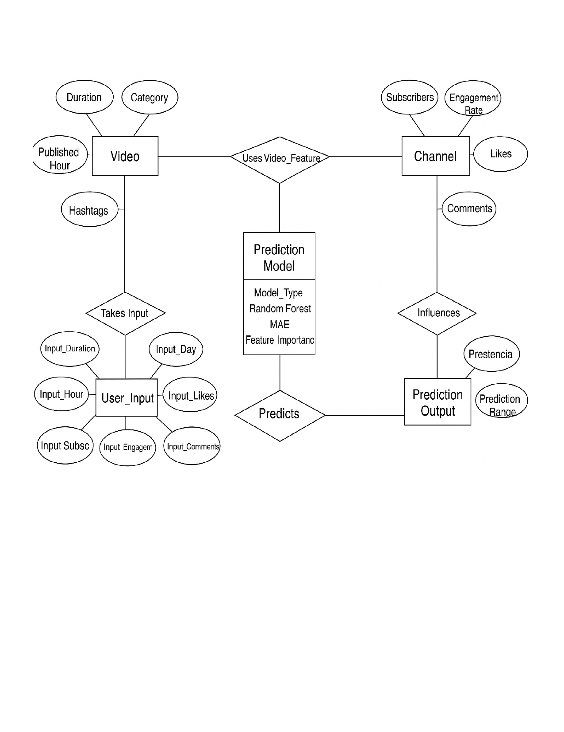

  - UML Diagrams:
Unified Modeling Language (UML) diagrams are used to represent the system design visually. They describe the structure, interactions, and behaviour of the system from multiple perspectives. The following UML diagrams were prepared for this project.

    - Use Case Diagram:

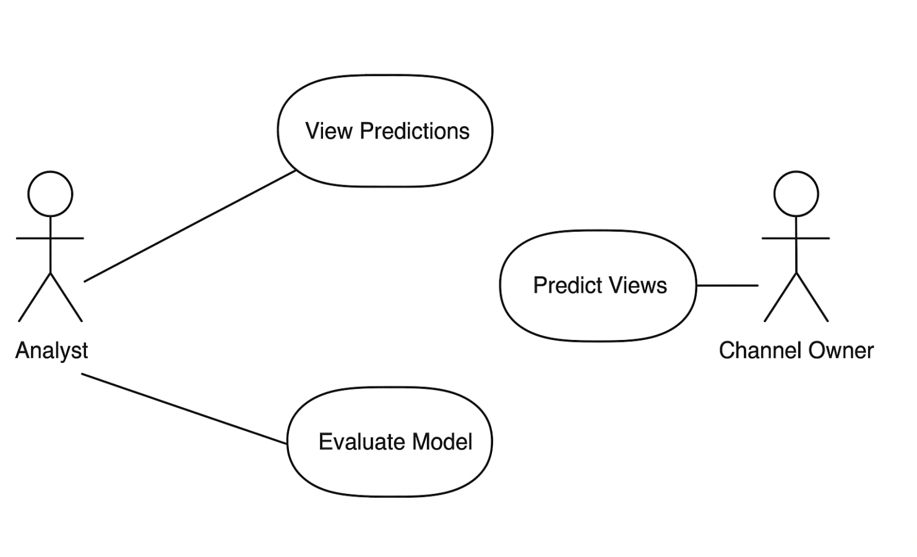

4.3.2 Class Diagram:

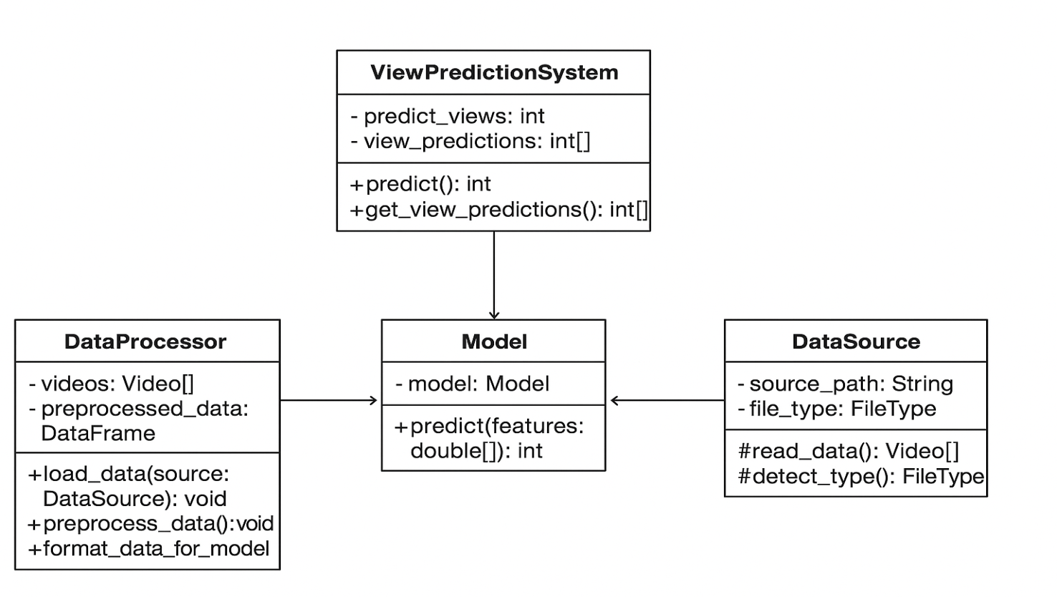

4.3.3 Sequence Diagram:
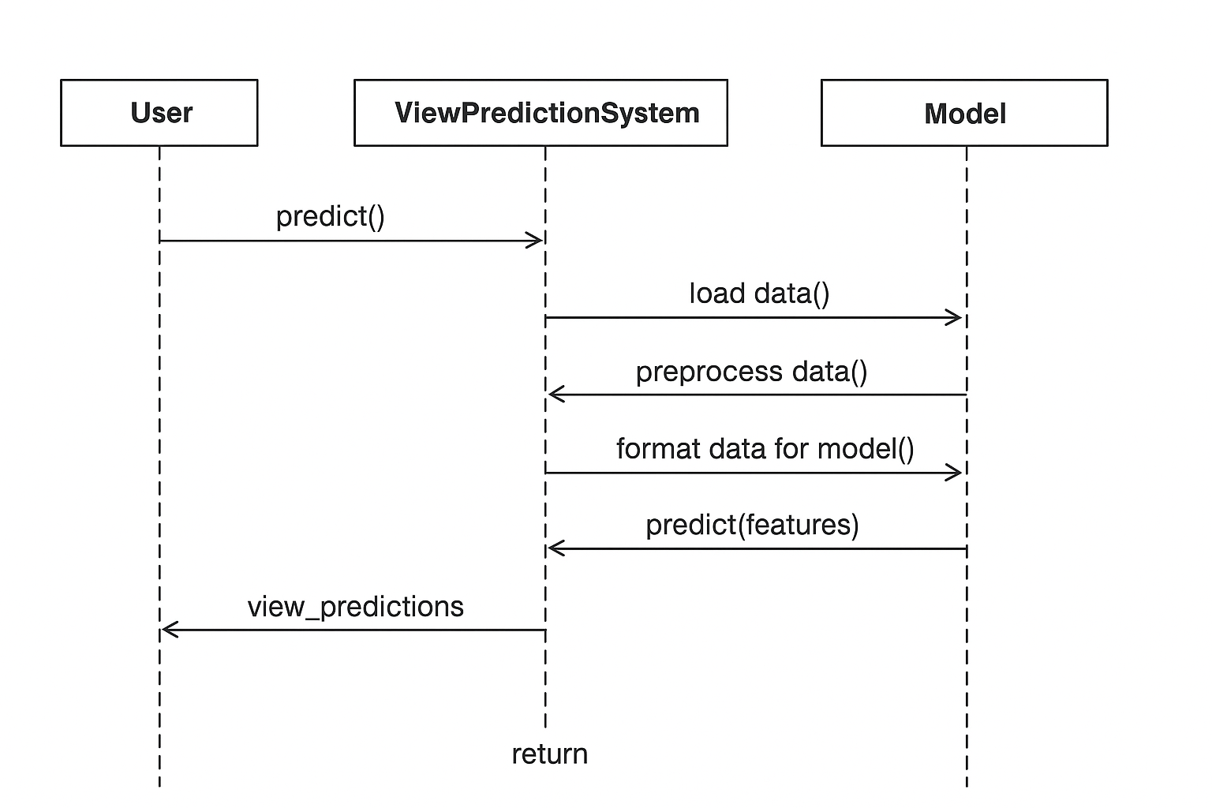
Project Screen Shot :

1.Input Page:
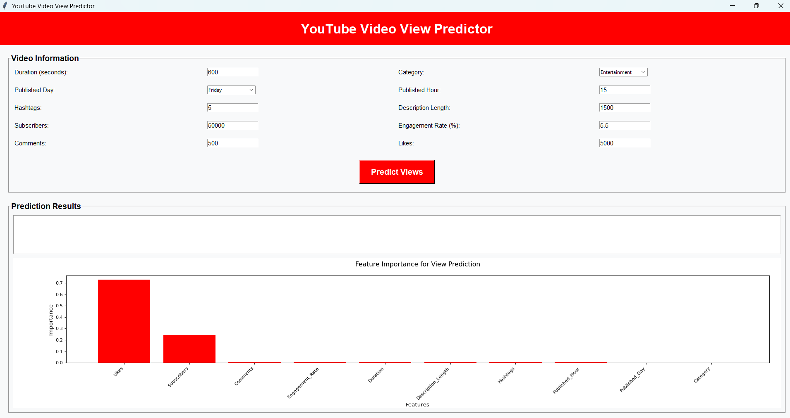

2.Add Video Information:

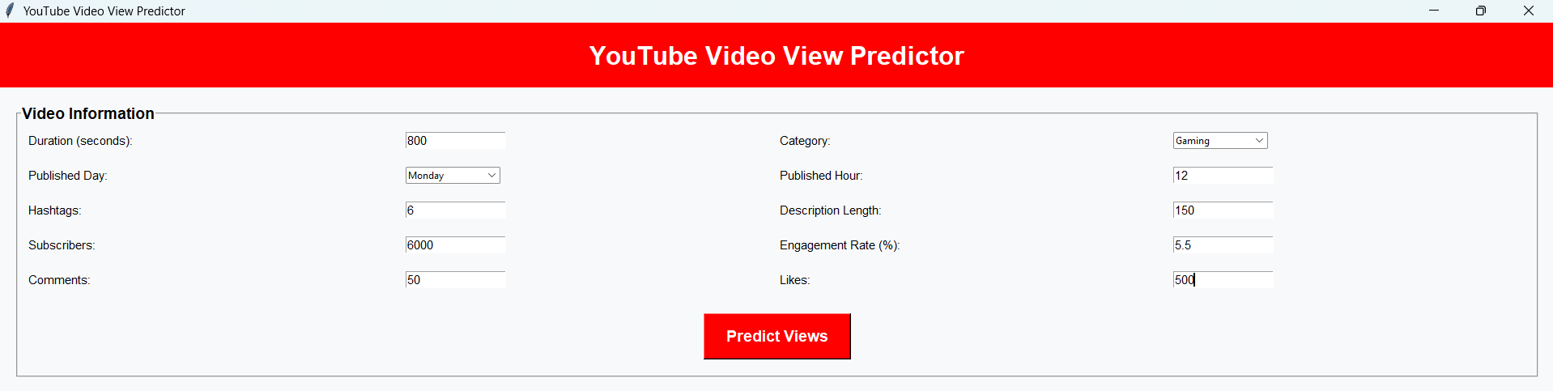

3.Prediction Result:
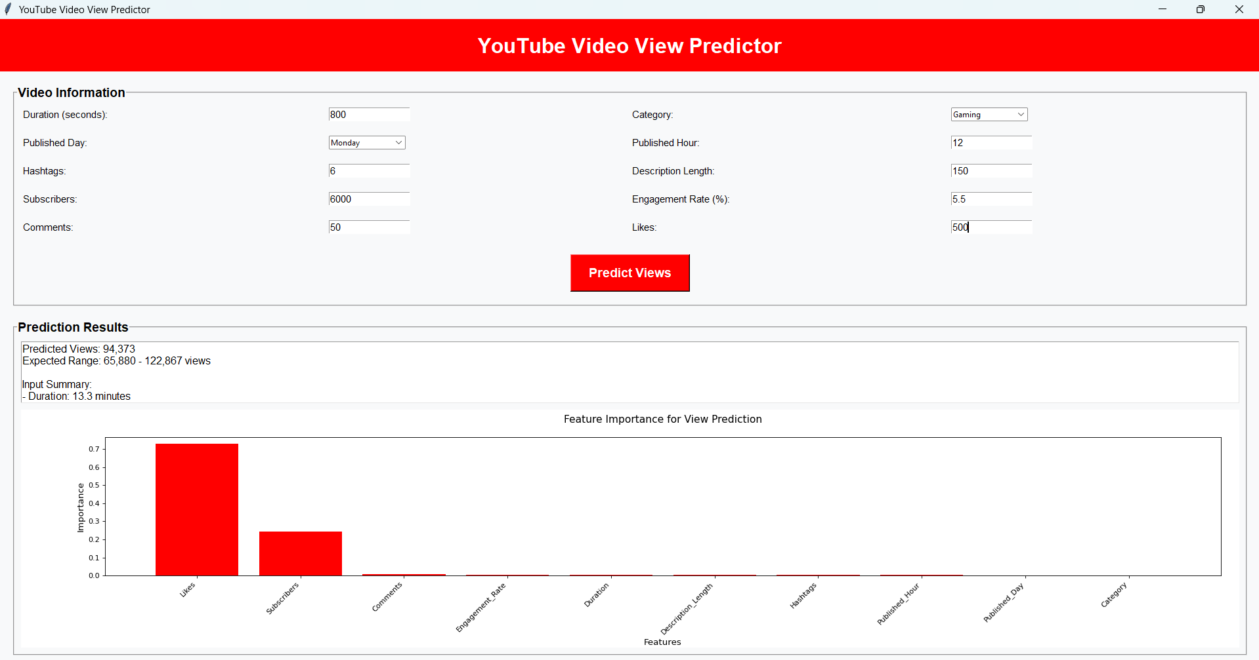

4.Output:
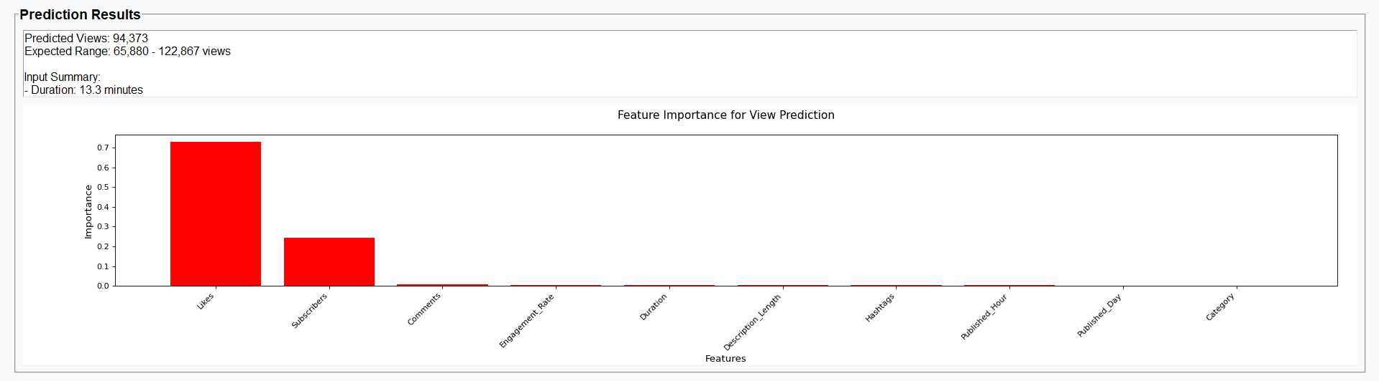

Coding / Implementation
  - Algorithm / Steps:
The following steps describe the implementation process of the YouTube Video View Predictor system:

Data Collection:
  - Collect dataset containing information such as:
    - Video Duration
    - Category
    - Publishing Time
    - Subscriber Count
    - Engagement Rate
    - Likes
    - Comments
    - Total Views (target variable)
  - Data can be obtained from YouTube API or public datasets available online.

Data Preprocessing:
  - Handle missing and duplicate values.
  - Encode categorical features (e.g., Category) using Label Encoding or One-Hot Encoding.
  - Normalize numerical values for better training performance.
  - Split data into training and testing sets.

Feature Selection:
  - Select key influencing factors affecting views, such as:
    - Duration
    - Category
    - Publishing Time
    - Subscriber Count
    - Likes
    - Comments

Model Selection:
  - Use regression-based algorithms for prediction, such as:
    - Random Forest Regressor
    - Linear Regression
    - Decision Tree Regressor
  - Random Forest is chosen for better accuracy and handling of complex relationships.

Model Training:
  - Train the model using the training dataset.
  - Adjust hyper parameters like the number of estimators and depth of trees for optimal performance.

Model Evaluation:
  - Evaluate performance using metrics such as:
    - Mean Absolute Error (MAE)
Compare results of different models to choose the best performing one.

Prediction Phase:

  - Accept user inputs through the desktop GUI (Tkinter interface).
  - Model predicts the estimated number of views.

Output Display:
  - Display predicted view count on GUI.
  - Provide a comparison chart or success message.

  - Software and Hardware Requirements:
- Software Requirements -
Component: | Specification:
Operating System - | Windows 10 or above
Programming Language - | Python 3.8+
Frontend (GUI) - | Tkinter
Machine Learning Libraries - | Scikit-learn, Pandas, NumPy
Visualization Libraries - | Matplotlib, Seaborn
IDE / Editor - | PyCharm / VS Code / Jupyter Notebook
Database (Optional) - | SQLite / CSV file for data storage
Version Control - | Git (optional)
- Hardware Requirements -
Component: | Specification:
Processor - | Intel Core i3 or higher
RAM - | Minimum 4 GB (8 GB recommended)
Hard Disk - | Minimum 250 GB
Monitor - | 15” Color Monitor
Input Devices - | Keyboard, Mouse
Output Devices - | Display Screen

  - Modules in the Project:

- Data Collection Module -
  - Handles importing and loading of YouTube dataset.
  - Verifies data format and quality.

- Data Preprocessing Module -
  - Cleans, encodes, and normalizes the dataset.
  - Removes null or duplicate entries.

- Feature Selection & Training Module -
  - Selects most impactful features for prediction.
  - Trains machine learning model (Random Forest Regressor).
  - Saves trained model using joblib or pickle.

- Prediction Module -
  - Takes user input via GUI (video duration, likes, comments, etc.).
  - Loads the trained model and predicts number of views.
  - Displays predicted value to the user.

- GUI (Frontend) Module -
  - Developed using Tkinter.
  - User-friendly interface to input video parameters.
  - Displays output prediction in a neat format.
  - Includes buttons for “Predict”, “Reset”, and “Exit”.

- Visualization Module (Optional)-
  - Generates graphical charts to show relationships between features and views.
  - Helps in better understanding of data and prediction trends.

6. Testing
Testing is a crucial phase of the YouTube Video View Prediction System, as it ensures that developed model and the complete application function accurately, efficiently, and reliably. Throughout the project, different software testing techniques were applied to verify both the machine learning components and the system-level workflows. The testing process began with unit testing, where individual functions such as data preprocessing, feature extraction, and the prediction method were examined to confirm that they worked as expected and produced correct intermediate results. Once each component was validated, integration testing was carried out to ensure that the modules interacted smoothly, such as data flowing correctly from preprocessing to feature engineering, and from model training to the prediction module.
After successful integration, system testing was performed to evaluate the entire project as a complete system. This type of testing ensured that the end-to-end workflow from inputting video attributes to generating predictions was functioning properly and meeting the defined requirements. Functional testing was also conducted to verify that the system fulfilled its intended purpose, such as accepting user inputs correctly, generating accurate predictions, and displaying the results in a clear and user-friendly manner. Since the project involves a machine learning model, validation testing played an important role. The dataset was split into training and testing sets, and cross-validation was used to check whether the model generalized well on unseen data. Additionally, performance testing was conducted to assess the speed of prediction and the overall responsiveness of the system. As the system evolved, regression testing ensured that updates or new features did not negatively affect the existing functionality. Finally, user acceptance testing was carried out to confirm that the system was intuitive and met user expectations in terms of usability and usefulness.

6.1 Black Box / White Box Testing
- Black Box Testing:
  - Black Box Testing focuses on checking the functionality of the application without knowing the internal logic or code structure.
  - Testers provide various inputs and check whether the outputs match the expected results.
  - It is mainly applied to test:
    - Prediction results
    - Error handling

- White Box Testing:
  - White Box Testing involves testing the internal logic, code structure, and data flow within the application.
  - It was mainly applied during the development phase to verify:
    - Data preprocessing logic.
    - Algorithm performance and error-free execution.

  - Manual / Automated
Manual Testing:

Manual testing was performed on the Tkinter GUI and input validation process.

- Testers manually entered various input combinations for duration, likes, comments, category, etc.
- Observed system responses and verified results.
- Ensured proper GUI behavior (buttons, labels, result box, etc.).

Examples:
- Ensuring the “Predict” button works only when all inputs are valid.
- Observing system crash handling with extreme values.

Automated Testing:
Automated testing was applied to the ML model for accuracy verification and regression testing.

- Python’s unittest and pytest libraries were used for writing test scripts.
- Scikit-learn’s metrics (mean_absolute_error, r2_score) helped measure prediction accuracy.

Objectives:
- Verify model’s performance consistency on new data.
- Ensure trained model file (.pkl or .joblib) loads correctly.

Testing Summary:
Type of Testing | Objective | Status
Unit Testing - | Check each module independently - | ✔ Completed
Integration Testing - | Verify combined working of modules - | ✔ Completed
Functional Testing - | Validate GUI and input/output correctness - | ✔ Completed
Performance Testing - | Ensure model predicts efficiently - | ✔ Completed
User Acceptance Testing - | Ensure ease of use and reliability - | ✔ Completed

7.Result and Discussion
This chapter presents the results obtained after the successful implementation and testing of the
YouTube Video View Predictor system.
The model was trained using machine learning algorithms to predict the approximate number of views a YouTube video might receive based on parameters such as video duration, category, time of publishing, number of subscribers, likes, comments, and engagement rate.
  - Predicted vs Actual Values
The performance of the selected model was further validated by comparing predicted and actual view counts for the test dataset.

Video ID | Actual Views | Predicted Views | Difference
V101 | 50,000 | 49,800 | 200
V102 | 72,000 | 71,100 | 900
V103 | 35,000 | 36,200 | 1,200
V104 | 1,20,000 | 1,18,900 | 1,100
V105 | 65,000 | 64,700 | 300

Observation:
The predicted values closely match the actual values, confirming the model’s effectiveness in identifying view patterns from input features.

  - Discussion
From the results and analysis:

- The Random Forest algorithm provided the best balance between accuracy and computational efficiency.
- The system successfully predicts views with high accuracy for diverse categories such as Education, Entertainment, and Technology.
- Engagement-related attributes (likes, comments, subscriber count) were found to be the strongest indicators of future views.
- The Tkinter GUI enhances usability, making it suitable for creators, marketers, and researchers.
- The system performed efficiently during stress testing, showing consistent results and stable performance even after repeated predictions.

8.Conclusion and Future Scope
  - Conclusion
The YouTube Video View Prediction System successfully demonstrates how machine learning can be used to analyze video-related data and accurately predict future view counts. By collecting and preprocessing relevant features such as title, tags, duration, likes, comments, and publishing details, the system builds a predictive model capable of identifying patterns that influence video popularity. The project highlights the importance of data quality, feature engineering, and model evaluation in developing reliable prediction results. Overall, the system provides an efficient and user-friendly way to estimate video performance, helping creators, marketers, and businesses make informed decisions about content strategy and audience engagement.

  - Future Scope
Although the system performs efficiently, there are several possibilities for future enhancement and development:

Integration with YouTube Data API:
  - The system can be extended to automatically fetch real-time data (likes, views, comments) from YouTube channels through the official API instead of manual input.

Web-Based or Cloud Deployment:
  - The project can be upgraded from a desktop application to a web-based platform or cloud-based analytics dashboard for easier access and scalability.

More Predictive Features:
  - Future versions could include additional input parameters such as video tags, title sentiment analysis, description keywords, or thumbnail quality, which can strongly influence viewership.

Real-Time Analytics Dashboard:
  - Incorporating live charts and data visualizations to help users analyze how changes in factors (likes, comments, duration) dynamically impact view predictions.

Mobile Application Development:
  - The system can be ported to a mobile app for accessibility and ease of use by content creators on the go.
References
1. YouTube Data API – Google Developers
https://developers.google.com/youtube/v3
2. https://dl.acm.org/doi/10.1145/1298306.1298311
3. https://dl.acm.org/doi/10.1145/1935826.1935878
4. https://dl.acm.org/doi/10.1145/2433396.2433440
5. https://dl.acm.org/doi/10.1145/2187836.2187840
6. https://thesai.org/Publications/ViewPaper
8. https://ojs.aaai.org/index.php/ICWSM/article/view/14706

